Hill cipher

# Definition

Hill cipher is an algorithm which uses as encryption key a square matrix and decryption key its inverse.

Alphabet: space and a-z

The encryption/decryption rules are as follows, supposing the length of the alphabet is 27:

Plaintext: four

Numerical: 6 15 /21 18

Encryption: 3 18 /15 24

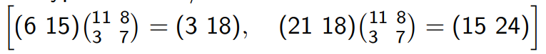

Ciphertext: crox

# My application

The application consists in a window containing 1 text field for the plain text 2 buttons, one for encryption one for decryption, one text area for the result and 2 more text fields for dimension of the matrix and the elements of it.